Proportional-Integral-Derivative (PID) controllers are used in most automatic process control applications in industry today to regulate flow, temperature, pressure, level, and many other industrial process variables.
They date back to 1939
They automate regulation tasks that otherwise would have to be done manually

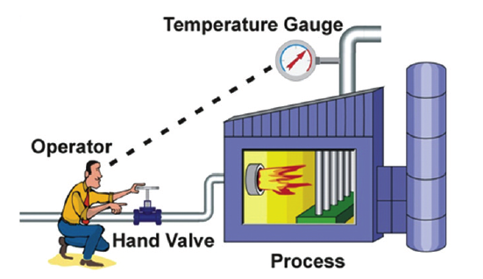

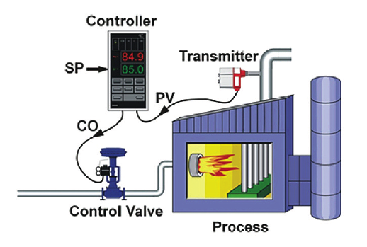
For example, when you want to drive your car at 65 mph, you depress the accelerator until the speedometer reports the target speed — simple. But what happens when you start driving up a hill? The car slows because the torque to move a car at 65 mph on flat road is no longer enough — so you respond by pressing the accelerator further down. Or, if you are going downhill you wouldn’t need to keep pressing the accelerator because there is enough momentum built up. Your foot, the speedometer, and your brain have formed a control loop. American cars have offered automated speed control loops — also known as cruise control — since 1958.
What this does for a steamer:
- Provides the brain, the foot and the accelerator to produce the correct amount of steam to cook … no less & no more… just what is needed… eliminating the excess steam going down the drain requiring tempering water.

- The result:

- Significantly less water usage – approx. 90% less
- Less water means less water treatment.
- Same cook times as an ala cart steamer, using less water

